April 18, 2023
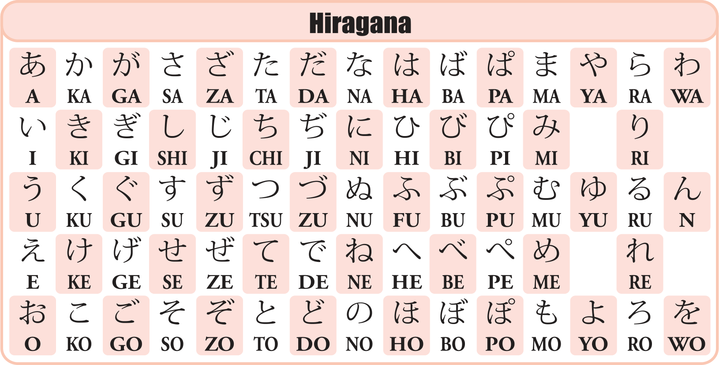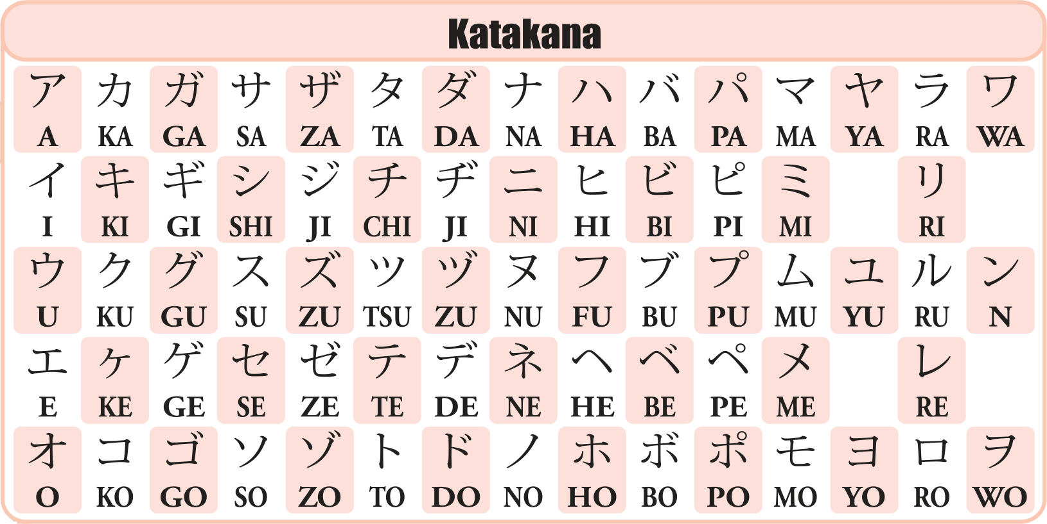
Hiragana / Katakana
Tomotada Ohtsuki
Yusuke Kuno
Jun Murakami

