Why I Resist Part of the Oath – by Dror Bar-Natan, July 19 2013, last edited September 23, 2013. Web version at http://drorbn.net/Canada/Response.
On July 12, 2013, the Ontario Superior Court of Justice heard a lawsuit brought by myself and two other applicants, Michael McAteer and Simone Topey, and ably presented by our lawyer Peter Rosenthal, to allow us to become Canadian citizens without having to affirm a part of the Oath of Citizenship – the first part, about the Queen and all:
I swear (or affirm) that I will be faithful and bear true allegiance to Her Majesty Queen Elizabeth II, Queen of Canada, Her Heirs and Successors, and that I will faithfully observe the laws of Canada and fulfil my duties as a Canadian citizen.
A decision on the case is pending within a few months.
In the days since July 12, I have read a very large number of responses; many of which, quite negative. The purpose of this note is to explain my point of view and to answer the critics to the best that I can. I am writing for myself and while the opinions of the other applicants may be similar to mine, they are definitely not bound by my words.
As some of what I’ll say may seem critical of Canada, the obvious and most important should be stressed up front. Canada is a wonderful country and a great place to live - as a whole, better than any other country I’m aware of (and I’m well-travelled, so I speak with some authority). I could spend some time justifying this “Canada is Great” statement I just made. Instead allow me to cash on my credibility, exactly that credibility that I don’t want to dilute by taking a certain part of the oath and affirming what I don’t believe in. I ask you to believe that I really mean it, and that at least subjectively, for me, Canada is wonderful. Along with the fact that I live here and work here, that’s why I want to become a Canadian citizen, and that’s why I am ready to faithfully observe the laws of Canada and fulfil my duties as a Canadian citizen.
I should probably also acknowledge the obvious, that I’m not a monarchist. While the reasons why I object to the monarchy are largely irrelevant, for in a democracy I ought to be allowed to object to the monarchy for any reason whatsoever or for no reason at all, let me still use this opportunity to state those reasons. To me the monarchy is a symbol of inequality. Some people are born with privilege they cannot ever lose. The privilege is stamped on them; it stays forever. This is just the same and just as unjust as having a class of people on whom disprivilege is stamped forever. It is a remnant of times bygone, in which aristocracy was aristocracy, peasants were peasants and slaves were slaves, indefinitely. I do have some other objections, but that’s the biggest.
Yes, I admit, the Canadian monarchy is far away and rather benign. Canada is as close as it gets to a true democracy; if it was anything else, I could not have made the statement “Canada is wonderful” in good conscience, and I would have never come here to live. Left alone I would have perhaps complained sometimes among my friends about having a monarchy, but I would have never bothered to write an essay on matters monarchical. There are plenty of other things I would rather do.
Yet for no compelling reason, and definitely against my conscience, in the country in which I live I am required to mouth support for a monarchy before I can vote. Had I not taken my words seriously, I would have taken the oath some five years ago, when I first became otherwise-eligible for Canadian citizenship. But I do take my words seriously and I find it hard and bitter to imagine myself making a well-considered public statement that by no means can be interpreted jokingly, in support of a symbol I cannot agree with. This should not be necessary in a democracy.
So yes, I object to the monarchy part of the oath for the selfish reason that I cannot take it without feeling humiliated. Had it not been for that part of the oath, I would have likely become a citizen and stayed in my office, teaching my students and working quietly on my esoteric research in mathematics.
That was my moral case. What is the legal case? My lawyer is better than me at explaining it, and this he did already, in court. Most of the relevant documents, all that I could get my hands on, are on my web site at http://drorbn.net/Canada, under “Quick Links”. The gist is that the oath contradicts our freedom of conscience and religion (the “religion” part applies to one of the other applicants more than it applies to me). It also contradicts our freedom of speech in two ways. By forcing unwanted (and in no way trivial!) speech upon us, and then, if we are to take the words of the oath with any amount of seriousness, by committing us to abstain from speech on our opposition to the monarchy forever after. Finally the oath discriminates against us relative to native-born Canadians, as they (with some exceptions) are not required to take the oath and are not bound by it. The freedoms of conscience and of religion, the freedom of speech, and the freedom from discrimination, are all protected by the Canadian Charter of Rights and Freedoms, which takes precedence over the oath, which is not in itself mandated by the Canadian constitution.
To be fair, the Charter of Rights and Freedoms allows for exceptions. Freedoms are guaranteed only subject to “such reasonable limits prescribed by law as can be demonstrably justified in a free and democratic society”. Once rights and freedoms have been limited, the onus of proof is on the government, to show that these limitations are demonstrably justified in a free and democratic society. I believe that the government failed to do so in the court hearing last Friday, and my feeling is that this is because the task it is facing is impossible.
Indeed consider the following. A sizable fraction of the Canadian citizenry does not believe in the monarchy. Many other democracies live quite well without an oath to a monarch, including a few constitutional monarchies, including our closest likeness in the Commonwealth, Australia. The monarchy part of the oath has no practical meaning, for the government of Canada has never done anything to enforce that part, and thus its meaning has never been defined by actions. In fact, one affiant in our case, Ashok Charles, publically recanted the first half of the oath a number of years after taking it, and was told by the government that he could keep his citizenship as he did not break any law. So how exactly will the government prove that the first half of the oath is necessary in a free democratic society?
Scratching out the first half of the oath, or replacing it by a simple statement of allegiance to Canada itself rather than a surrogate, or making it a choice, is simple and harmless; it does not require a significant rewriting of Canadian laws and requires no meddling with the constitution. Polls suggest that many Canadians do not believe in the monarchy. While no polls are available on the opinions of new Canadians, it stands to reason and it is confirmed by my personal experience, that many new Canadians mouth the first half of the oath only because they have to, because they know it has no effective meaning and because they need that citizenship document. Scratching or improving the first half of the oath will only serve to strengthen the second half of the oath, which I hope is universally respected by all Canadians and would-be Canadians. (If the government agrees one can recant the first half of the oath after taking it, can one also recant the second half afterwards?).
Let me move on to answering the critics, as best as I can. Every point below is taken from some critical article or letter I have read since July 12.
“But the Charter does not apply to non-citizens”. That’s nonsense, legally and morally. If that statement was legally true, the court would have thrown out our case at a preliminary stage of the process. And morally, much of the Charter to the best of my understanding is the opinion of Canada on human rights anywhere and everywhere, including in the middle of the Sahara desert. Canadian jurisdiction does not extend to the middle of the Sahara, so it is not the business of Canadian courts to guarantee rights there. But we applicants are well within Canadian jurisdiction and hence the rights promoted by the Charter fully apply to us.
“How dare you non-citizens meddle with the terms of your own citizenship? This is a matter for Canadian citizens to decide”. Once again, legally, if that were true, the court would have thrown out our case a long time ago. In fact, quite clearly only non-citizens have legal standing for the purpose of our lawsuit, for the law that we are challenging does not apply to citizens. Sure, we could wait for enough citizens to slowly come to appreciate our plight. But we are wronged now. When exactly would the remedy come if we so wait? And please remember that all that we are doing is to ask the court to note that one law is in partial contradiction with another, the Charter. The Charter that was drafted by you, Canadians. Note also that while we are not citizens, all of us could have been citizens a long time ago, barring for the first half of the oath. I’ve lived in Canada for 11 years so far (legally, of course), and I could have easily been a citizen for at least 5 years. Ms. Topey had been here 35 years, since 1978, and is a permanent resident since 1981. Mr. McAteer is a permanent resident here since 1964 (ouch, longer than I have lived!). We are not uncommitted newcomers who barely know what Canada is about.
“This is not a matter for the courts but for the political system”. In some sense, you are right. Yet experience shows that politicians don’t care about non-voters. If we will wait for the politicians, it will be a long wait indeed. I’d like to add a positive note about Canada. Over the years I have had the chance to observe the immigration services of several other countries, mostly through the experiences of my family, friends, students, and scientific colleagues. These services are often unpleasant to the immigrants they serve or manage, always because immigrants are weak and powerless. Immigration Canada is in fact quite fair. Yet change without a court’s ruling? That’s too much to ask for.
“But the oath is a part of our tradition”. Traditions are to be observed, not to be enforced. And some traditions are not to be observed and not to be enforced. A club that traditionally admits only Caucasian Anglicans may need some re-thinking.
“Why can’t you just take the oath and forget about it”. What would you say, if you were deeply protestant (or if you are deeply protestant), and you were asked to solemnly acknowledge the supremacy of the Pope in a public ceremony, even if you could retract your oath on the following day?
“This is Canada. Take it or leave it”. But this is not Canada. The Charter, which is a part of the constitution, says one thing and the oath, which is not in the constitution, says another. The constitution trumps.
“Didn’t you know Canada was a monarchy when you first came?” I knew, of course. I also knew and still know that much more than a monarchy, Canada is a true democracy that upholds the values of freedom of conscience and freedom of speech. I wasn’t aware of the specifics of the oath at the time, and I hope to find that my stronger perception of Canada, that of a true democracy, will prevail.
“But Queen Elizabeth embodies Canada. An oath to the Queen is equivalent to an oath to Canada”. Perhaps some legal reasoning may attempt to justify such a statement. But it is still wrong. To test this statement experimentally I made two web-searches for images, one for the keywords “Queen Elizabeth”, and one for the keyword “Canada”. Here are the results, unedited except to fit the page:
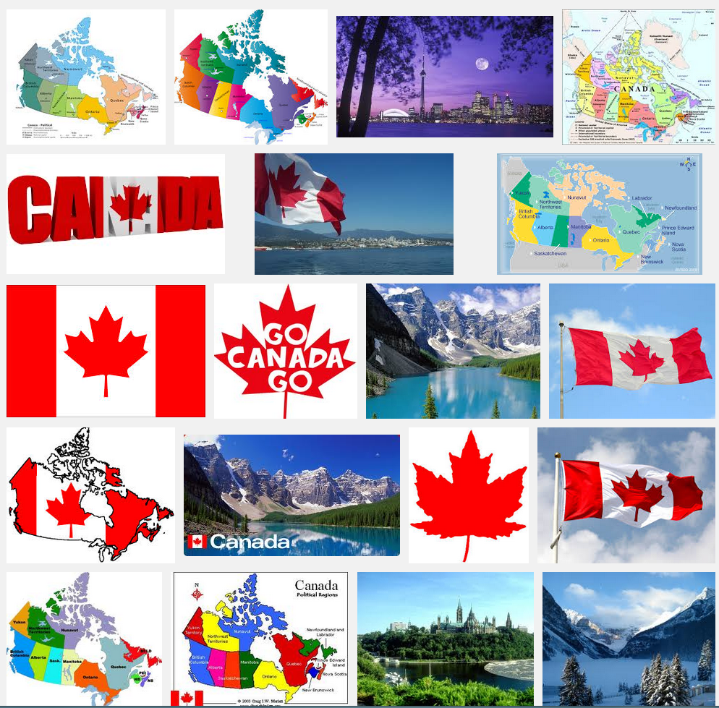 | 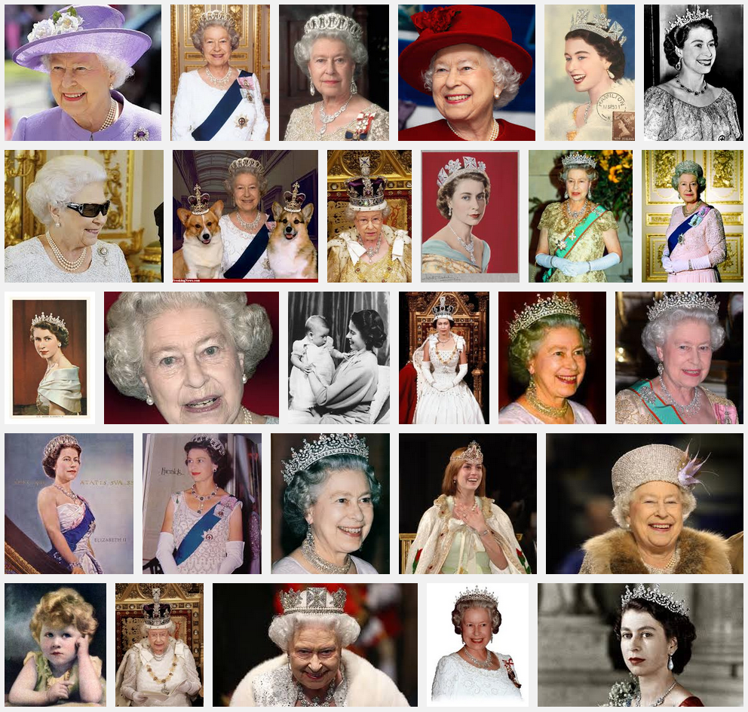
Sorry, an oath to one is not the same as an oath to the other.
(Incidentally, I found no pictures of the Queen within the Canada search results, even scrolling hundreds of images down, and very many other things came instead: maps, flags, landscapes, inuksuit, canoes, waterfalls, hikers, bears, RCMP officers, buildings, fireworks, lighthouses, boats, trains, skiing slopes, airplanes, sporting events, ducks, stores, factories and so much more.)
“If the oath is unconstitutional, then so is all of our money, many stamps, numerous parks and streets and perhaps the City of Regina’’. I have visited the city of Regina. It is very hard to interpret this as having stated an opinion of any kind on the monarchy. It is hard to interpret taking an oath of allegiance to a queen as not binding me in allegiance to a queen.
“What will you do if your legal challenge will fail?” I don’t know. Joyful it will not be.
I’d like to conclude with two of the email messages I have received over the last few days from people I did not know before; both are quoted here in full. The first, by Richard Fellows of Vancouver, BC, comes with no comments:
I'm just writing to thank you for the stand that you are taking with Michael McAteer and Simone Topey. I am from England and have been in Canada for 13 years and I think I would be a citizen by now if it were not for the oath to the queen. I just don't think I can bring myself to say those words. Please pass on my thanks to Michael and Simone too (I don't have their email addresses). I'm sure that the three of you have had to put up with a lot of anti-immigrant bigotry. Whether you win or lose your case, you have done the right thing. You are clearly thoughtful and principled people and are therefore exactly the kind of people that Canada needs as voting citizens.
The second message was much simpler. In fact, it consisted of just one word, spelled in caps:
LEAVE
With so little to work with, it is hard to tell what thinking really lies behind this message. Yet I fear that there may be a small component of xenophobia hiding there. We live in the 21st century. Moving between countries remains taxing, but it is much easier than it used to be, and many more do it. Immigrants from Hong Kong launch startups in Canada, while Canadians may be powering great things in Brazil. If more Canadian brain will be moving out of Canada than foreign brain will be moving in, Canada stands to lose. Canada is my home; I hope this will not happen.

Added September 21, 2013. I have learned yesterday that the Ontario Superior Court of Justice decided against us. I have read court’s “reasons for judgement” (a 21 page document available at http://drorbn.net/Canada). Needless to say, I will have to read it a few more times and along with the other applicants and our lawyers we will have to decide whether and how to appeal. Yet here’s my preliminary response.
To the best of my understanding the main reason for the court’s decision is the court’s view that the words of the oath don’t actually mean what they say, but something else. It is for our lawyer to argue with that on the legal level; I can only apply to common sense.
Come on. The oath says “… be faithful and bear true allegiance to Her Majesty Queen Elizabeth II, Queen of Canada, Her Heirs and Successors…”. This is a rather detailed and specific statement. How can it be taken to mean anything other than that it is a pledge to be faithful and bear true allegiance to the monarchy, forever? To the best of my understanding, the court suggests that the very explicit reference to a person in the oath, along with her heirs and successors, should not be read as a reference to a person but as a reference to the country of Canada and its constitutional order. Sorry, but it is not within the power of the court to change the meaning of words in the English language. Countries and constitutional orders may well have heirs and successors in some historical sense, but the heirs and successors the oath is referring to are clearly flesh and blood.
Compare with the first few words of that very same oath, “I swear (or affirm) that…”. As the court notes, “swear” would have been the word of choice for the authors of the oath. Yet realizing the religious meaning of the word “swear” the authors have chosen to add the “affirm” option. But if words could be freely laundered, as the court seems to believe, why couldn’t “swear” be re-interpreted to mean “affirm” or “pledge”? But words can’t be laundered, and so “affirm” was explicitly allowed.
In the same manner, if the oath does not imply allegiance to a person, it cannot be phrased as implying allegiance to a person. If it meant to say “allegiance to Canada”, it must say – or at least leave the option to say - “allegiance to Canada”. What’s wrong with that? Isn’t it actually much truer and lovelier?

Dror Bar-Natan is a Professor of Mathematics at the University of Toronto. He got his BSc from Tel-Aviv University in 1984, his PhD from Princeton University in 1991, and then worked for 4 years in Harvard University, 6 years in the Hebrew University and one year in Berkeley before coming to Toronto in 2002.

