MAT 257
Moved to
MC 254
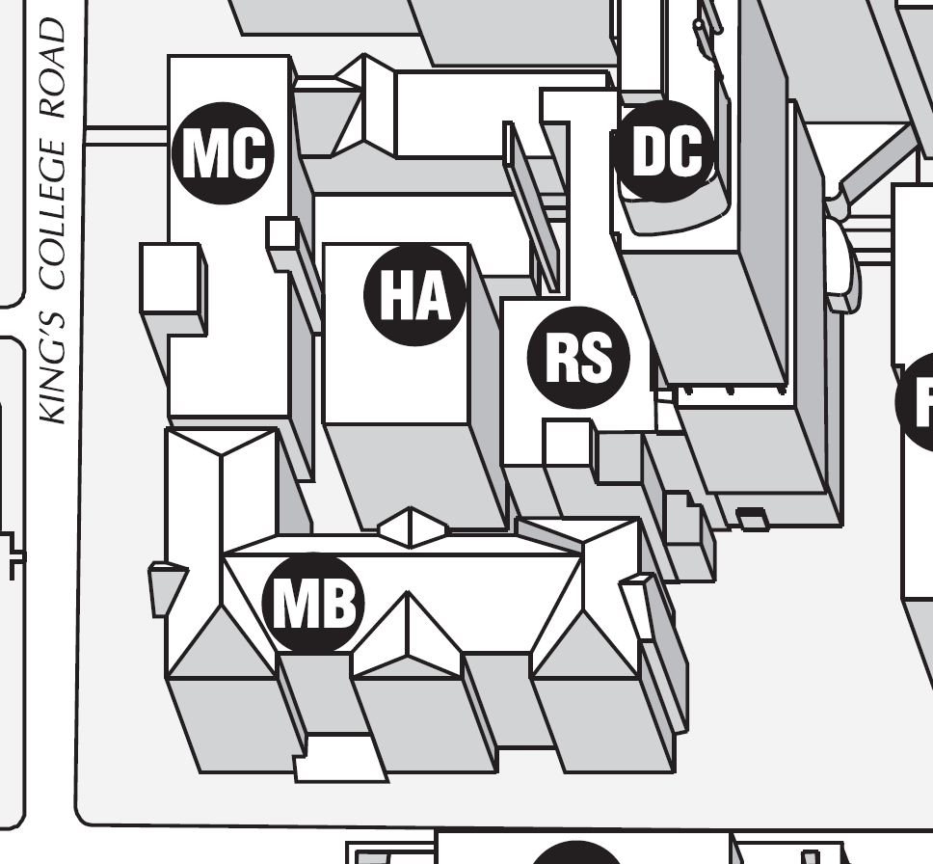
For the rest of this semester

